Assignment 4

Output

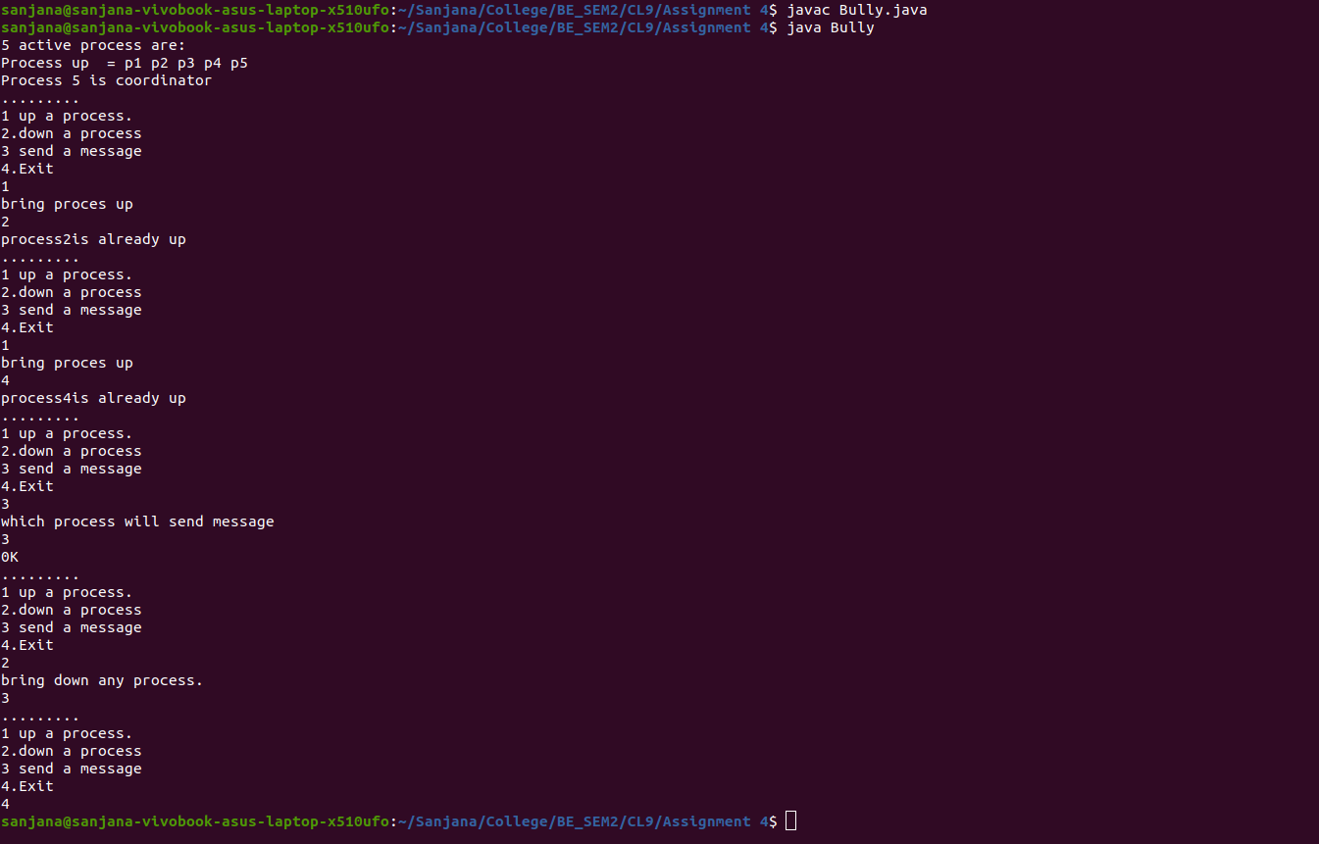

Bully.java

import java.io.InputStream;
import java.io.PrintStream;
import java.util.Scanner;

public class Bully {
static boolean[] state = new boolean[5];
int coordinator;

public static void up(int up) {
if (state[up - 1]) {
System.out.println("process" + up + "is already up");
} else {
int i;
Bully.state[up - 1] = true;
System.out.println("process " + up + "held election");
for (i = up; i < 5; ++i) {
System.out.println("election message sent from process" + up + "to process" + (i + 1));
}
for (i = up + 1; i <= 5; ++i) {
if (!state[i - 1]) continue;
System.out.println("alive message send from process" + i + "to process" + up);
break;
}
}
}

public static void down(int down) {
if (!state[down - 1]) {
System.out.println("process " + down + "is already dowm.");
} else {
Bully.state[down - 1] = false;
}
}

public static void mess(int mess) {
if (state[mess - 1]) {
if (state[4]) {
System.out.println("0K");
} else if (!state[4]) {
int i;
System.out.println("process" + mess + "election");
for (i = mess; i < 5; ++i) {
System.out.println("election send from process" + mess + "to process " + (i + 1));
}
for (i = 5; i >= mess; --i) {
if (!state[i - 1]) continue;
System.out.println("Coordinator message send from process" + i + "to all");
break;
}
}
} else {
System.out.println("Prccess" + mess + "is down");
}
}

public static void main(String[] args) {
int choice;
Scanner sc = new Scanner(System.in);
for (int i = 0; i < 5; ++i) {
Bully.state[i] = true;
}
System.out.println("5 active process are:");
System.out.println("Process up = p1 p2 p3 p4 p5");
System.out.println("Process 5 is coordinator");
do {
System.out.println(".........");
System.out.println("1 up a process.");
System.out.println("2.down a process");
System.out.println("3 send a message");
System.out.println("4.Exit");
choice = sc.nextInt();
switch (choice) {
case 1: {
System.out.println("bring proces up");
int up = sc.nextInt();
if (up == 5) {
System.out.println("process 5 is co-ordinator");
Bully.state[4] = true;
break;
}
Bully.up(up);
break;
}
case 2: {
System.out.println("bring down any process.");
int down = sc.nextInt();
Bully.down(down);
break;
}
case 3: {
System.out.println("which process will send message");
int mess = sc.nextInt();
Bully.mess(mess);
}
}
} while (choice != 4);
}
}

